|  |  |
| --- | --- |
| ***MEETING MINUTES*** |  |

**SCRIBE:** Gaby Tulchinskaya

**PROJECT:** GreenSheets Re-Design

**MEETING NAME:** GreenSheets Re-Design Kickoff Meeting

**ATTENDEES:** OGA:Crystal Wolfrey, Stacey Kocher, Eugenia Chester,

CBIIT: Nelya Gunina, Jennifer Kwok, Gerald Momplaisir,

Subashini Varadarajan, Yakov Polonsky, Larry Brem,

Gaby Tulchinskaya.

**MEETING DATE/LOCATION:** 08/11/2016; 9609 Medical Center Dr., Meeting Room # 1W032/034

**Purpose of the meeting:**

* Quick overview of combined CBIIT OGA scope of the project
* Follow up on revised awards (Additional questions and clarifications)
* On conceptual level discuss greensheets versioning and select reconciliation method (if needed)

**Discussion and decisions**:

|  |  |
| --- | --- |
| **Topic** | **Decision** |
| Quick overview of combined CBIIT OGA scope of the project | Using draft, provided by CBIIT, OGA will come back with own version of the combined scope that will have priorities for each high level feature. |
| Follow up on revised awards | * Link to Revision greensheet will be provided in eGrants when Revision greensheet status is ‘Frozen”. * No changes, related to revised awards, are needed in YourGrants and Notification systems |
| On conceptual level discuss greensheets versioning and select reconciliation method | 1. When new Form Builder template is promoted, the GreenSheets system behavior will be:   If greensheet is in status “**Not Started**” => Latest version of template (latest questions) is displayed  If greensheet is in status “**Submitted” or “Frozen**” => Version of template on the moment of submission is displayed. Read-only mode  If greensheet is in status “**Saved**” (see mockups below the table):   * A user will see the latest version of template * System will automatically match the answers/comments/attachments for the questions that did not change. No partial reconciliation is needed * System will display a warning message that the template has changed and instructions to a user. OGA need to provide the message text. * Prior version(s) will NOT be displayed in read-only mode * The system will provide ability to copy attachments that were saved before the template has been promoted. There is no need to display related questions and, thus, no need to have saved prior version of questionnaire. Ability to copy attachments is a nice to have feature; CBIIT will evaluate LOE. * After submission of the greensheet, all previously saved attachments (not related to current version) will be deleted   If greensheet is in status “**Unsubmitted”** => Same as in scenario “Greensheet is in status “Saved”   1. Report in FormBuilder that ties the version of template to type/mech should have an “expiration date” (when new version got promoted). It will be easier to query later |

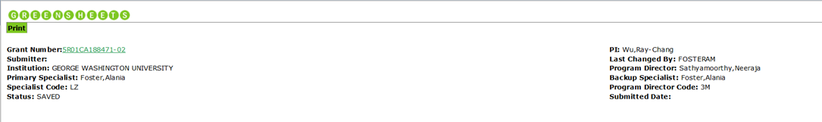

**The greensheet template has been updated and the questions might have changed. The system automatically matched the answers and attachments to the questions that did not change (if any). Please check for correctness and enter answers to the updated questions.**

To copy attachment (if exists) that were saved before the template was updated, click on attachment icon on this screen for a selected question. **NOTE: after submission of this greensheet, all prior attachments that were not copied will be DELETED.**

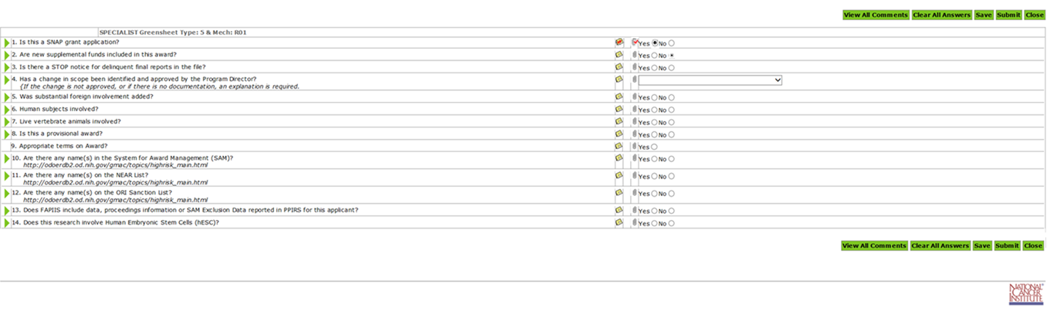

When user clicks attachment icon in CURRENT version window for a specific question and any attachments have been saved prior to promotion of the new template, the system will provide ability to see and copy all prior attachments:

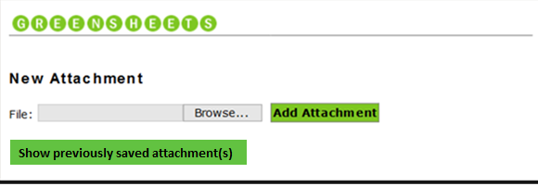

When user clicks “Show previously saved attachment(s)” button, the system displays them;



|  |  |
| --- | --- |
| **File Name** | **Action** |
| Attachment name 1.docx | Copy |
| Email PDF1.pdf | Copy |
| Doc3333.doc | Copy |

**Attachment File List**

|  |  |
| --- | --- |
| **File Name** |  |
| Attachment name 1.docx | Delete |
| Attachment name 22.docx | Delete |
| File that user added manually into a current version.doc | Delete |

